Secondary Education Reform in Taiwan:
Comparing the Perceptions of Teachers and Students between 2011 and 2021
Abstract
This mixed methods study compares how secondary school teachers implemented the 12-year Basic Education Reform in Taiwan in 2011 and 2021. Major sources of were surveys from sample teachers and students in sixteen sample schools. The survey asked how often a teaching or evaluation strategy was used. The conclusions of both studies indicate that teacher-directed lessons (teacher talk and questioning) dominated. The use of student-centred learning (SCL) methods (activities and group work) was limited. However, almost 30% of the sample students in both studies stated that the behaviour of students in the classroom was affecting their work. A major obstacle for the reform remains high-stakes examinations, which rely heavily on rote memorization, rather than the creative application of knowledge. Educators in all jurisdictions can learn from the reform efforts.
Keywords: education reform; international education; student-centered learning (SCL); classroom management, high-stakes examination
I hear and I forget, I see and I remember, I do and I understand −Confucius

Introduction
In the 1990s, large-scale education reform orchestrated by provincial, state, or national governments emerged around the world. Whitty, et al. (1998) and Fullan (2000) studied system reforms in Australia, England, Finland, New Zealand, and the United States. Each country had its unique history and context, but all of the governments introduced large-scale reforms that sought to improve instruction and develop closer links between objectives, programs, teaching, and student evaluation. Author et al. (2012, 2013ab, 2019, 2020, 2021, 2023) have examined secondary reforms in Canada, China, Sierra Leone, the Philippines, the Caribbean, and Mexico. The studies concluded that teachers are ready to change and respond positively if they think that the reform is justified. Key hindrances to reform implementation were contextual issues such as large classes, a lack of resources and professional development. According to Schweisfurth (2011), “student-centered education (SCL) has been a recurrent theme in many national education policies in the global South” (p. 425). In a recent meta-analysis of the international literature on SCL, Bremner (2021) found that 'active participation' is the most mentioned element when it comes to conceptualizing SCL. It has become an influential education movement adopted in many countries, and now Taiwan.
Reform in education often demands changes in practice that challenge classroom teachers (Fullan, 2000). These changes require teachers to possess the knowledge and skills to implement curricula with confidence (Wiles & Bondi, 2014). Teachers initially report feeling overwhelmed and under-supported (Helsby, 1999; Lasky & Sutherland, 2000). These feelings occur because changing the curriculum and the resultant transitioning require teachers to alter the “specific blueprint for learning that is derived from the desired results—that is, content and performance standards” (Wiggins & McTighe, 2005, p. 5-6). Changing classroom practices and adopting more SCL pedagogies involve instructional improvement and resources. Educational reforms increase tension as outcomes are measured and results are evaluated against standards. These changes can trigger resistance, debate, and passivity among teachers. Teachers play key roles in reform as the agents of change who work directly with students (Clarke, 1997; Fullan, 2001). Fullan (1996) explained, “We need to first focus on how teachers make sense of the mandates and policies because there will be no educational reform until after the teachers interpret the policies and make decisions based on their beliefs about the new demands” (p. 12). We must also pay attention to the impact of reforms on students (Earl Sutherland, 2003). To date, other than those by the Author et al., little research directly sought the views of students as compared to those which have reported the wide range of teachers’ views on problems with educational change. We cannot deny the credibility of students as expert witnesses of effective instruction. Recommendations from the National Association of Secondary School and Sizer (2004) suggest that listening to students can be an effective strategy for school improvement. The report also encourages teachers to use a variety of instructional strategies including SCL activities. Fullan and Stiegelbauer (1991) posed the question: “What would happen if we treated the student as someone whose opinion mattered in the introduction and implementation of reform in schools?” (p. 170). This study provides a glimpse of secondary education reform in Taiwan by listening to the voices of students and teachers.
Taiwan Secondary Education
Taiwan is an island with 23.5 million people, rapid economic development and thriving industries. Education is positioned as a tool for the empowerment of Taiwanese citizens, and as a mechanism to “ensure Taiwan’s global competitiveness” (MOE, 2014). The performance of its students in various international assessments (PIRLS, TIMSS, PISA) is remarkable. These results show that Taiwanese students excel in reading literacy, science, and mathematics. That makes Taiwan a good case study to explore SCL approach to education in the 21st century. The education system in Taiwan has a 6-3-3-4 structure. In 2014, the Senior High School Education Act extended basic education from nine to twelve years, increased educational opportunities for all students and created diversified pathways. School curricula have mostly emphasized content and focused heavily on examinations which reward rote memorization rather than the creative application of knowledge (Lin, Wang & Chang, 2014). Students in the final year of junior and senior high school had to pass the national senior high school and university entrance examinations respectively. These high-stakes tests often determine future academic and career pathway options. Average class size in Taiwan was around thirty in 2021.
Literature review
Key-Competencies Education
Table 1: Comparison between Traditional and Competency Based Education
Traditional Education | Key-Competencies Education
Teacher-Centered Learning | Student-Centered Learning (SCL)
Remember the content and achieve learning goals through continuous practice. | Integrate knowledge, skills and attitudes to solve real-life problems.
Emphasize the learning in each discipline. | Emphasize interdisciplinary learning.

Wu & Chan (2018) compared traditional education with key-competencies education (Table 1). The 12-Year Curriculum Guidelines recognize that students must take initiative to act autonomously, communicate interactively, and engage in social participation toward the collective good.
K-12 Educational Reforms in Taiwan
Since the 1990s, Taiwan’s Ministry of Education (MOE) has been steadily engaging in educational reforms to ensure that the education system reflects the changing needs of society and aligns with international standards. The 9-Year Curriculum Reform was implemented in 2001. It described ten fundamental competencies related to self, society, and nature, which reflected the goals to educate the “whole child” and to prepare students for a diversified, interconnected, and innovation-driven job market (Chen & Huang, 2017; Lin, Chuang & Hsu, 2014). School subjects were organized into integrated learning areas. Schools were given more discretion to develop individualized curricula. However, the rapid, top-down approach of the reform resulted in some confusion and pushback from teachers and the public. Some argued that the curricular competencies were too abstract and high-level for elementary and junior secondary students. Others stated that they were not accurate representations of essential life competencies (Chen & Huang, 2017). New demands are placed on teachers as they strive to implement the newly reformed competency-oriented curriculum with renewed pedagogical practices. The new curriculum gave teachers more autonomy to create their own teaching materials, but most teachers were not prepared (Coudenys, Strohbach, Tang, & Udabe, 2022).
The 12-Year Curriculum (also called the 108 Curriculum課綱) was implemented in 2019. Like its predecessor, the curriculum is shifting from content-based to competency-based with the feature of autonomy-centered curriculum enactment (Gouëdard, Pont, Hyttinen & Huang, 2020). The reform made several changes. First, the move challenged the traditional mode of teaching and learning via teacher transmission, making school curricula more flexible and student-centered. Second, the curriculum now focuses on integrating knowledge, skills, attitudes and interdisciplinary learning. Problem solving is emphasized in the classroom (Wang, Olivier & Chen, 2023). Courses help the student build self-identity from learning about his or her own culture and history and then connect with the international world. Third, instead of a curriculum developed at the national level, secondary teachers are encouraged to take into account student needs and community characteristics to develop their own curricula. The teachers use the School Actualization Program (SAP) based on a new national 12-year basic education framework (Chen, Yang, Hung, Hung & Chen, 2020). This move created more room for schools to take initiative to develop school-based curricula with local resources. Fourth, the senior high school entrance examination had to change (Fang, 2019). According the College Entrance Examination Center (2022), examinations will continue to have basic questions and literacy-oriented questions. The latter will include situational questions to assess whether students can integrate knowledge and skills, as well as questions with cross-unit/cross-field/cross-disciplinary themes. The new guideline also requires the inclusion and use of IT learning for every subject (Education International, 2022). Cho (2021), having gone through the curriculum as a student, outlined a few practical features:
- The school-developed courses encourage cross-curricular integrative content, project-based classes, and experiments.
- The inquiry and practice courses in social studies and natural science incorporate group activity periods.
- Elective courses include enrichment, expanded and remedial courses.
Student-Centered Learning (SCL) in Taiwan
Student-centered philosophy was introduced to Taiwan over thirty years ago. Numerous research studies on its implementation have been reported in early 2000. A reform policy document, the White Paper for Science Education (MOE, 2003), was implemented at K–12 levels where SCL became the central focus. Constructivist mathematics was implemented in the primary classrooms (Lin, Wang & Chang, 2014) despite criticism from stakeholders including teachers (Wu, 2001; Chiu & Whitebread, 2011). A large number of Taiwanese teachers strongly resisted the reform-based mathematics curricula. MOE gave it up after six years of implementation. Lai (2022) conducted a study to determine the cause. She demonstrated the importance of philosophy, rationale, and policy context in its implementation. The key reason for the failed implementation is that traditional mathematics classrooms emphasize fact and accurate performance and SCL is not suitable. Like their counterparts in mathematics, many secondary science teachers have reported feeling incompetent in implementing the new curriculum, as their professional training has not prepared them to teach using SCL constructivist strategies (Kyriacou & Chien, 2004). Huang & Asghar (2016) conducted an empirical qualitative study to investigate secondary science teachers’ perspectives on the reform and to determine how teachers negotiated the transition from teacher-centered to SCL approaches. Sources of data include individual interviews and reflective journals. Numerous reasons were found:
- Many teachers and parents feel that the SCL approaches are not compatible with Taiwanese cultural values (Baron & Chen, 2012).
- A majority of the teacher participants said that they were struggling with the conflicts in the transition.
Furthermore, the highly competitive examination system has led to a learning environment in which teaching and learning activities primarily focused on how to best prepare students for University Entrance examinations. In Taiwan, most parents still hold very high expectations for children’s performance (Fang, 2019). In fact, many parents enroll their children in evening or weekend “cram schools.” (Tsai and Kuo, 2008). Despite strong opposition to the reform, the Ministry of Education (MOE) continued to make efforts to implement SCL initiatives in Taiwan (Huang & Asghar, 2016).
Special Education
Taiwan has also prioritized reforms in special education to ensure inclusivity and equitable opportunities for students with special needs. MOE has increased resources for programs and implemented policies. The vast majority (96%) of students with disabilities study at regular schools and are integrated into regular classes. The others (4%) who need specific support services choose to study at special education schools (MOE, 2022). In accordance with the Special Education Act, “adaptability, individualization, socialization, accessibility, and inclusion must all be part of providing special education” (MOE, 2022, 6).
Rationale of the Study
The 12-year Basic Education Curricula was implemented in 2019. According to the MOE, “For the first time in the history of Taiwan, an integrated, cross-level, and interdisciplinary curriculum is in place to achieve the ideals of 12-year Basic Education” (MOE, 2021, 11). Sun (2020) and Gouëdard et al. (2020) conducted exploratory studies to interpret the policy. Results showed that its main rationale reflects the global trend to initiate curriculum reform to equip students with skills and competencies for the future. The current reform demands a paradigm shift from teacher-centered to SCL strategies and focuses on life experiences to cultivate students’ key competencies. Teachers in Taiwan become significant change agents throughout the reform process. There is a need to explore how teachers perceive the reform (Pan and Wiens, 2023). At the same time, the new curriculum promotes teachers as policy enactors and mediators rather than passive implementers. Consequently, a more “bottom-up” approach to curriculum implementation becomes necessary, and “implementation fidelity” used to measure the success of curriculum reform is replaced by an actor-oriented perspective (Penuel, Phillips, and Harris, 2014). With this new perspective of teachers as significant change agents throughout the current reform, this study is timely.
Objectives of the Study
The 12-Year Basic Education reform was implemented in 2019. In order to examine if significant changes have been implemented, this study compares and analyzes identical survey data obtained before and after the reform in 2011 and 2021 respectively. Areas of interest include curriculum planning, teaching strategies, assessment and evaluation strategies, integration of technology (IT), classroom management, special education, and high-stakes examinations. Two research questions related to the reform are:
- Compare the perceptions of students and teachers of the Secondary Reform in 2011 and 2021 in Taiwan.
- To what extent have teachers implemented the Competency-based Secondary Reform in Taiwan?
Findings and recommendations from this study will assist school administrators, teachers and parents in Taiwan and other jurisdictions in designing, adapting, and implementing exemplary practices in curriculum planning, teaching pedagogy, IT, and student evaluation methods, and high-stakes examinations.
Methodology and Data Collection
Major sources of data for this study were anonymous surveys for teachers and students. Sample questions involved the five-point Likert scale indicating how often a teaching and student evaluation strategy is used, and the amount of planning and support available. This study used a concurrent triangulation strategy (Creswell et al., 2003; Terrell, 2012). A survey was conducted which collected both quantitative and qualitative responses through open-ended questions. Surveys are commonly used to measure the implementation of large-scale reforms and how often certain strategies are used (Desimone, Smith, and Frisvold, 2010). Students and teacher surveys were used in previous reform studies by Author et al. (2011, 2013ab, 2019, 2020, 2023) and were modified and translated for the Taiwan Reform study. They are used to compare students’ and teachers’ perceptions of teaching and student evaluation strategies used before (2011) and after (2021) the implementation of the reform. All the items on the survey were analyzed quantitatively to answer the first research question. The open-ended questions in the surveys are related to teachers’ and students’ perceptions of changes in the reform. The results were content analyzed using thematic analysis technique. The qualitative findings were also used to corroborate the quantitative findings (Terrell, 2012) and answer the research questions.

Population and Sample.

Convenience sampling was used to collect data in both 2011 and 2021. The previous study in 2011 included fourteen sample secondary schools Findings and conclusions were reported in Author et al. (2011). This study reports findings from the current study and comparisons and analysis of the perceptions of the teachers and students in the implementation of reforms in 2011 and 2021. Twelve sample schools were selected for the current study. Schools were selected representing urban-rural and school types. Socio-economic status of the students as reported by sample teachers were: low (23%), middle (64%) and high (13%). At each sample school, 25 randomly selected teachers and two representative classes (approximately eighty students) were asked to complete separately designed surveys. Surveys are designed to provide a synthesis of what happens in the classroom. The return rates for the surveys were 98% (students) and 80% (teachers). However, due to the non-probability sampling, research findings were not generalized to populations but are presented as findings from the captive participants (Etikan, Musa, and Alkassim, 2016).

Results of the Study

Teachers’ Results
Sixty percent of the 293 teacher respondents in the current study (2021) were female. The mean teaching experience was sixteen years. The socio-economic status of the students according to the sample teachers was as follows: SES High - 13%, Medium 63% and Low 22%. Sample teachers were well represented in different subject areas and grade levels. The teachers used the internet and printed resources. The mean class size was 37 in both 2011 and 2021.

Comparison of the results from 2011 and 2021

Curriculum Planning
On average, just as they did in 2011, respondent teachers spent seven hours each week preparing for classes in 2021. In planning, an almost identical percentage of sample teachers (84% and 62%) stated that they received adequate resources and professional development respectively. To prepare for their lessons, in 2021, they depend on both the internet (87%) and textbooks (82%). These figures are more than they were in 2011 when 73% depended on the internet and 68% depended on textbooks.

Teaching and Student Evaluation Methods
Figures 1 and 2 compare sample teachers` self-reporting of the teaching and student evaluation methods they always/often used in 2011 and 2021. There is little variation in the teaching strategies over the nine-year span. The dominant strategies are teacher talk, individual work and questioning, all teacher-directed strategies. Discussion was always/ often used by 40% of the sample teachers in 2011 and 2021. Integration of Technology (IT) strategy was always/often used by about a third of the sample teachers. As for student-centered strategies (SCL), in 2021, close to a third (34%) of the sample teachers always/ often used activity learning, group work and experiments/demonstrations/skits. The latter two strategies have doubled from 17% whereas activity-learning remained the same at about 35%. In 2021, about 10% of the sample teachers claimed that they have classroom management issues as compared to 15% in 2011.
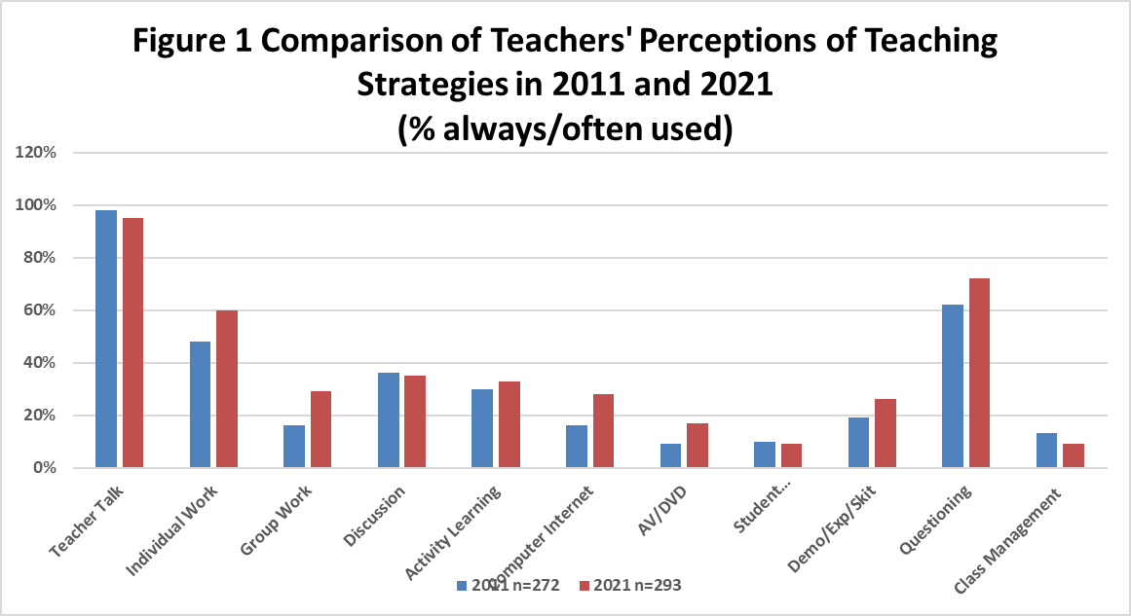
The predominant assessment strategies always/often used by sample teachers are tests, examinations, classwork and homework (Figure 2). However, in 2021, close to 20% fewer sample teachers always/often used traditional assessment strategies (tests, examinations and classwork) and adopted more strategies associated with SCL strategies (e.g. group work/projects and student presentations). Assignments/HW remained unchanged. These methods were also used by sample teachers to determine the final mark (Figure 3). The mean weightings provided by sample teachers in both 2011 and 2021 were quite consistent: assignments and class work (18% each), examinations (42%). However, weightings for tests were decreased by 4% in 2021, from 24% to 20%.
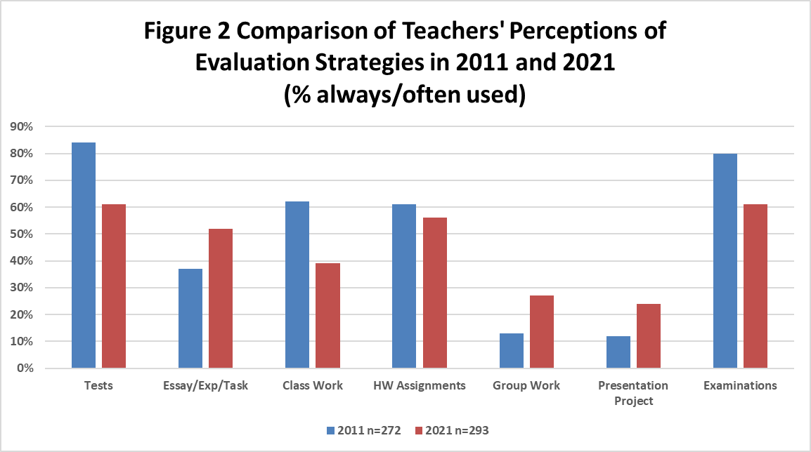
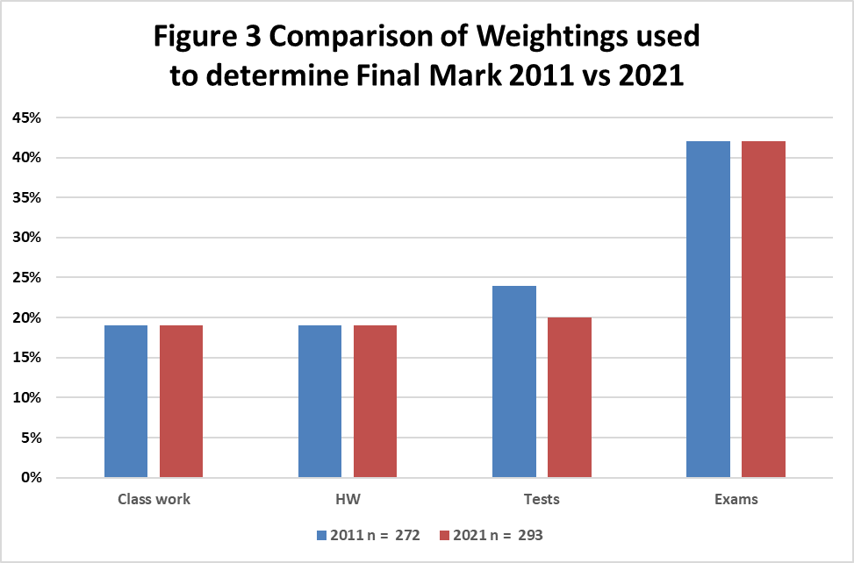

Student Outcomes
Sample teachers were asked to rate their perceptions of student outcome during class time. Results for 2011 and 2021 are shown in Figures 4 and 5 respectively. In 2011 (Figure 4), in reference to student concentration time, 42% of the sample teachers stated ‘satisfactory’. Fifty-three percent of teachers said ‘average’ and 4% indicated ‘unsatisfactory.’ Results for student work completion are similar: with 49%, 48% and 3% respectively. Results for student achievement are 47%. 52% and 1% respectively. Results for 2021 (Figure 5) are similar with more teachers expressing satisfaction with student concentration (49%) but fewer teachers stating that they were satisfied with the students’ achievement (38%).
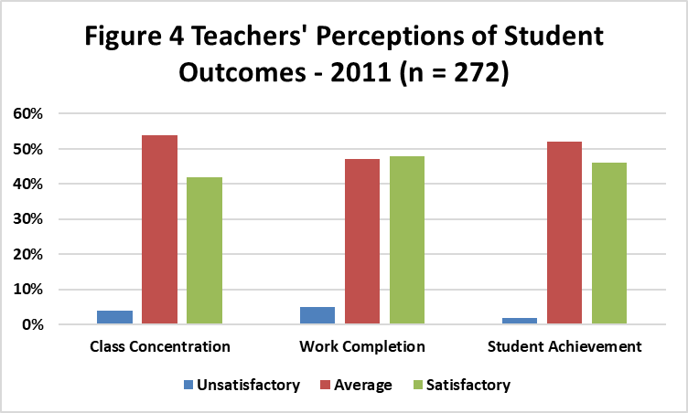
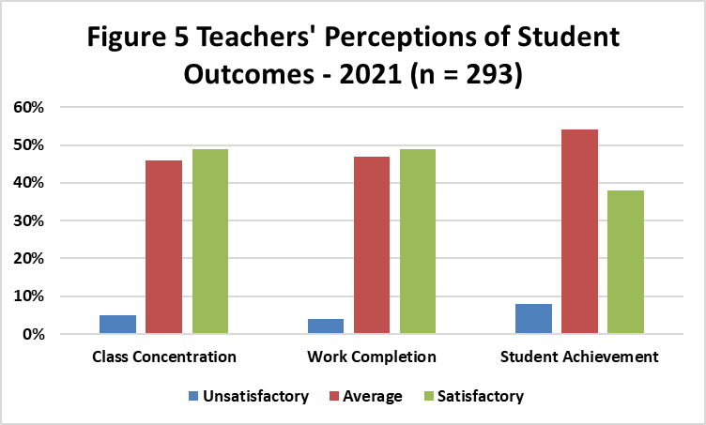

Special Needs Students
Sample teachers were asked to answer specific questions related to special needs students. In 2021, about half of sample teachers who had special needs students integrated in their classes replied to these questions. On average, each sample teacher had two students with learning disabilities, one behavioural learner, and one gifted student. Accommodation strategies used by sample teachers included modification (30%), extra time/help (28%), differentiation (12%) and adaptation (12%). All of these accommodations are in accordance with the Special Education Act (MOE, 2022).
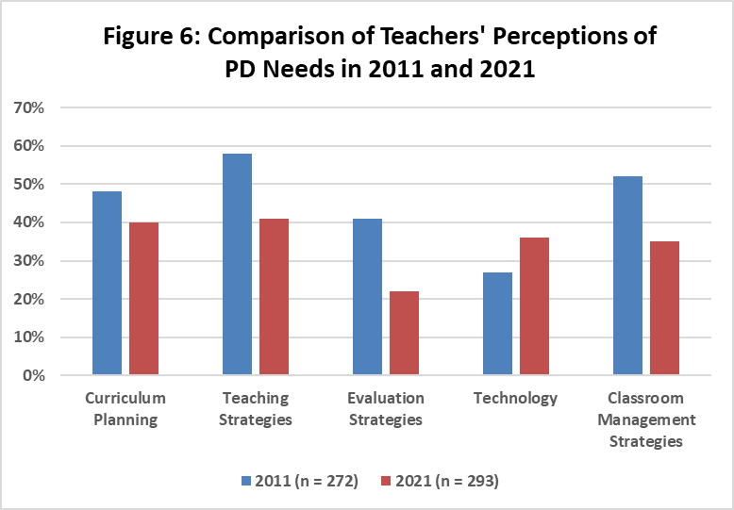

Satisfaction with Reform Implementation
In 2021, most sample teachers (54%) were satisfied with their courses and implementation. Only 5% were dissatisfied, and 41% were in between. Similar results were found in 2011 with a slighter higher (57%) satisfaction rate. When sample teachers were asked which of five areas needed improvement (Figure 6), the percentage was similar in all areas. However, more than one-third of the respondent teachers had greater need for professional development in classroom management techniques.

Students’ Results
Of the 667 student respondents from the twelve sample schools in 2021, most (75%) were from urban communities. There were more male students than female students (59% vs 41%). They spent on average two hours per day on homework/studying. Correlation between students’ perceptions of course variables in math is shown in Table 2. There were significant correlations between course performance and course interest (.63**), course difficulty (-.38**), course quality (.37**) and negative classroom behaviour (-.12**). This means that course performance was influenced by student behaviour, and the quality, interest, and level of difficulty of the courses as perceived by students.
Table 2: Correlation between Course Variables in Taiwan Student Sample (n = 667)
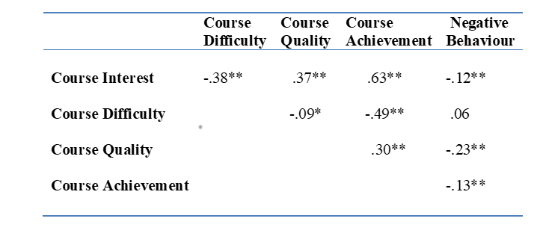
Figures 7 to 11 compared the students` perceptions of the teaching methods always/often used by their subject teachers in math, English, science, social studies, and Chinese in 2011 and 2021. Clearly the dominant teaching strategies used in all five subjects in 2011 and 2021, from the students’ perspective, were teacher talk (>90% always/often used in classes), individual work (40-50%), and teacher questioning (40-50%). All three are teacher-directed strategies. This is followed by discussions which was always/often used in about a third (33%) of the classes in both 2011 and 2021. SCL (group work and activity learning) and IT (Computer/Internet) strategies were used always/often in about a quarter (25%) of the classes in 2021. This figure was about a 10% increase from 2011. Classroom management issues remained at about 20-25% in all five subjects in 2011 and 2021 where sample students claimed that student behaviour was affecting their learning.
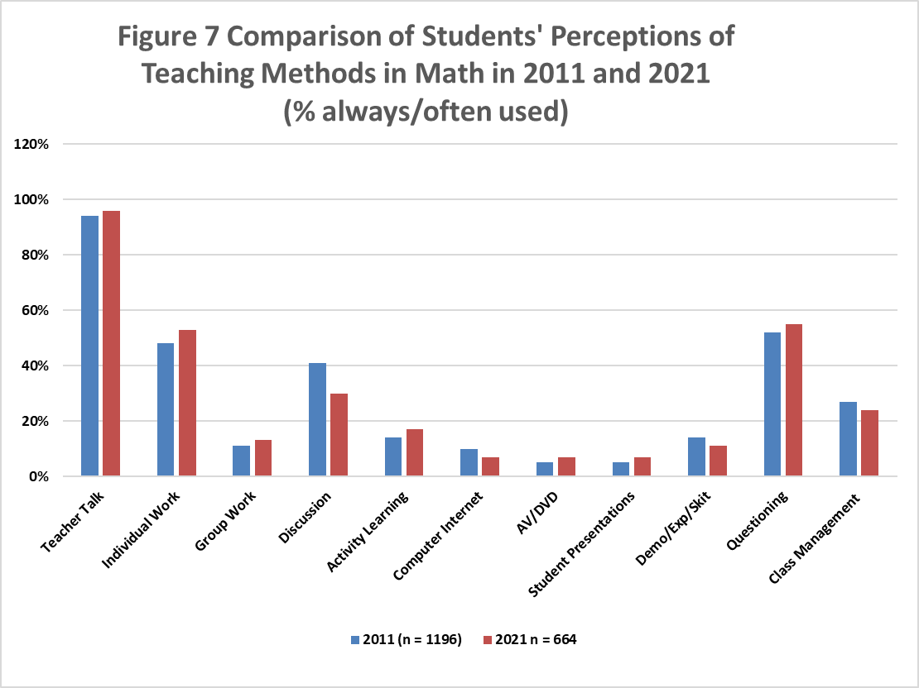
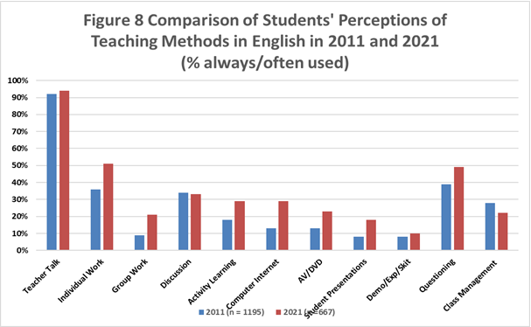
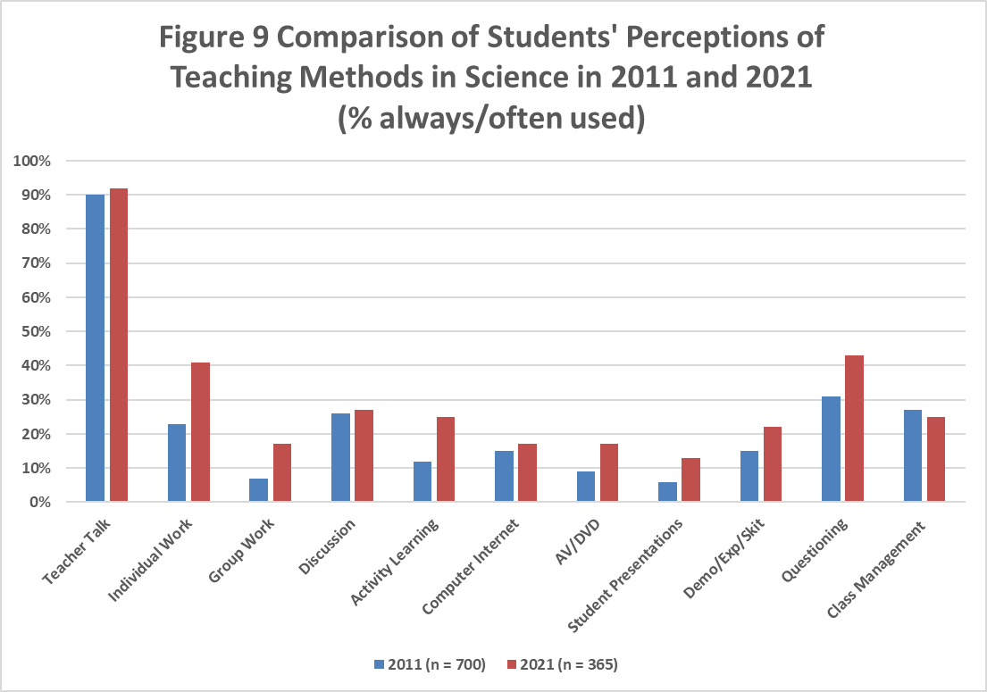
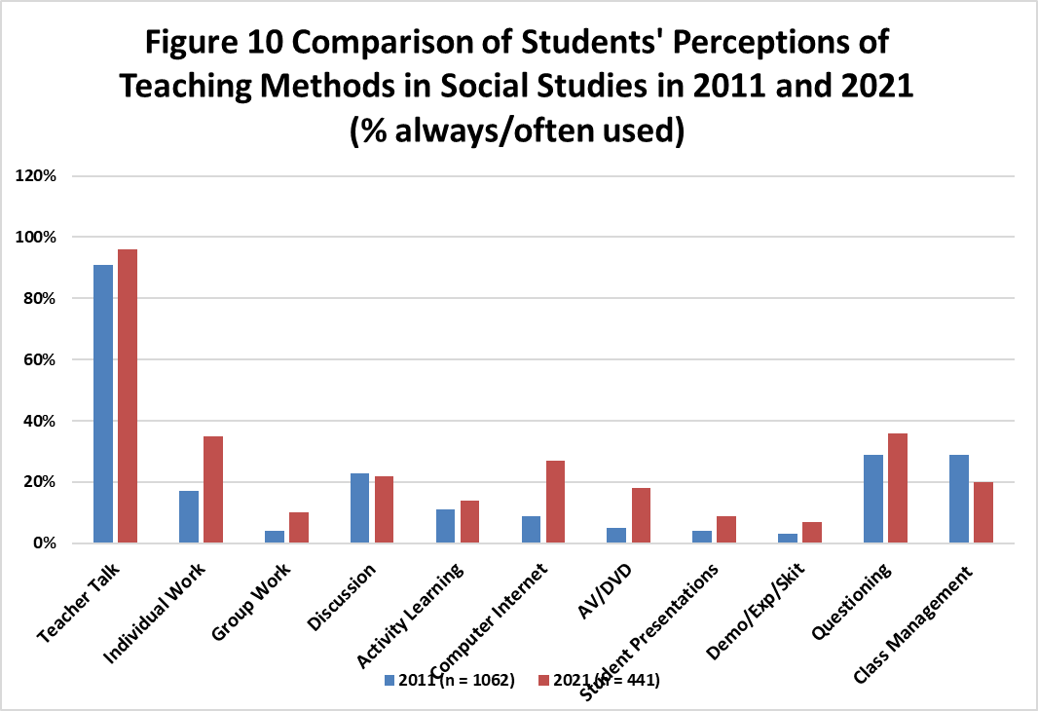
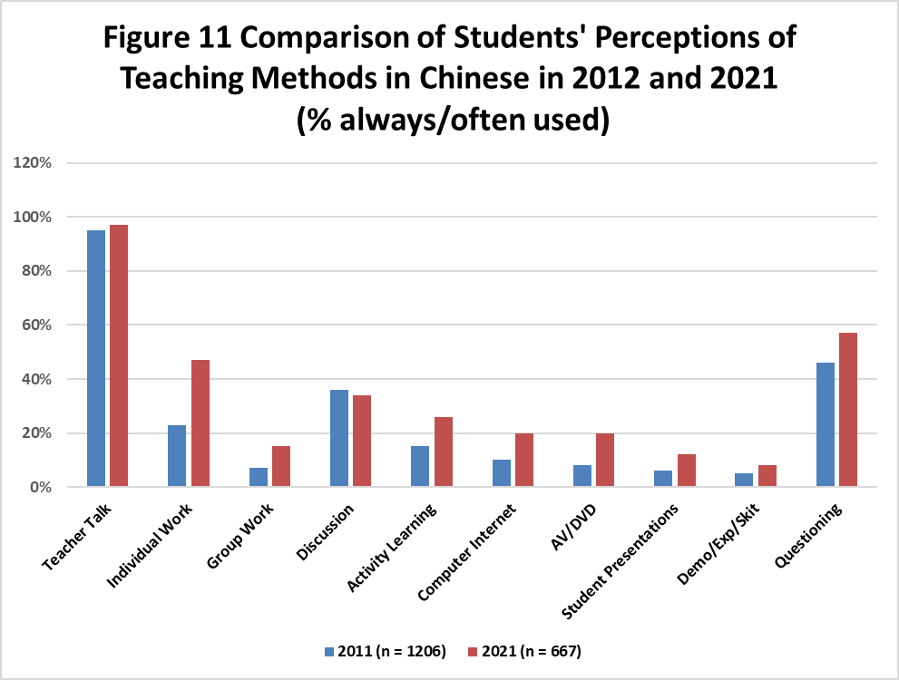
Data from Figures 7 to 11 are tabulated into Table 3 for easier and more accurate analysis. To determine the significance of the difference between the mean usage scores in 2011 and 2021, t-tests for independent samples were used for each strategy/subject. Percents in bold indicate significant difference between the mean scores (p = .05). Data from Table 3 can be used to confirm results obtained from Figures 7-11 using visual comparisons. For example, in English, Table 3 shows five strategies with bold percents, all of which indicate significant percent increases which meant more English teachers always/often used the strategy in 2021 than in 2011 or vice versa. Now examine those five strategies in Figure 7 (English). They have taller bars in 2021 than in 2011. In the same way, in math, discussion is the only significant decrease. Fewer sample students (41% to 30%) claimed that the strategy was always/often used by subject teachers in 2011. These results in English and math confirmed our earlier claims by examining the bar graphs. However, using t-tests to determine significant difference is more accurate than comparing lengths of bars in the graphs visually.

Table 3: Comparison of Students’ Perceptions of the Increase/Decrease in the Use of Teaching Strategies in Five Subjects (% always/often used from 2011 to 2021
(Numbers in Bold are significant (p = .05))
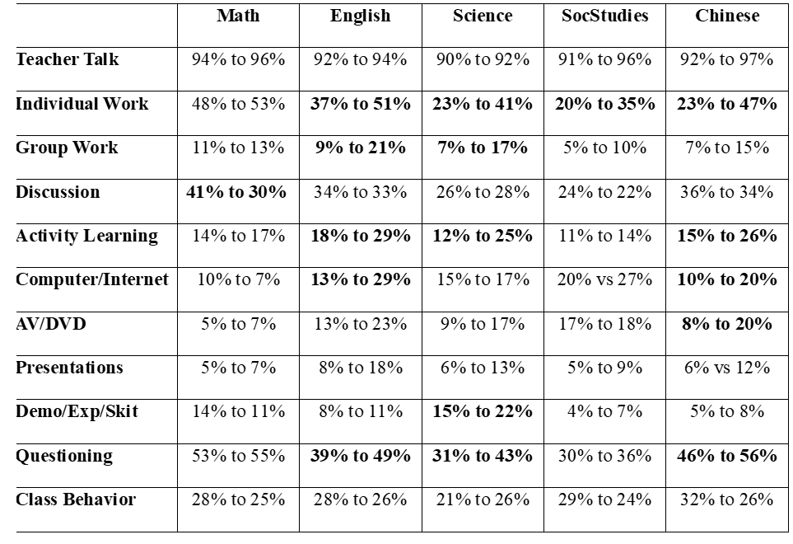
Increase use of SCL and IT
In Table 3, the five strategies in English with significant percent increases include two SCL strategies (group work and activity learning) and the use of the computer/internet. Two strategies with significant increase in social studies are the use of computer/internet and AV. The same results were seen in the Chinese course which has increased use of the activity learning strategy. The science course has significant increase in activity learning but no IT. However, it has significant increase in demonstration/experiment which is very important in science courses. Even though the significant differences are small (25-30%). It is something to build upon.
For the 12-year reform that focuses more on integration, interdisciplinary learning, problem solving and self, local and international awareness, SCL and IT are excellent teacher strategies. Another effective teacher strategy would be class discussion, which experienced a small increase also (25% to 35%, Table 3). In addition, these strategies would allow subject teachers to develop and implement school-based curricula with local resources (Wang, et al., 2023; Chen, Yang, et al., 2020).
High-Stakes Examinations
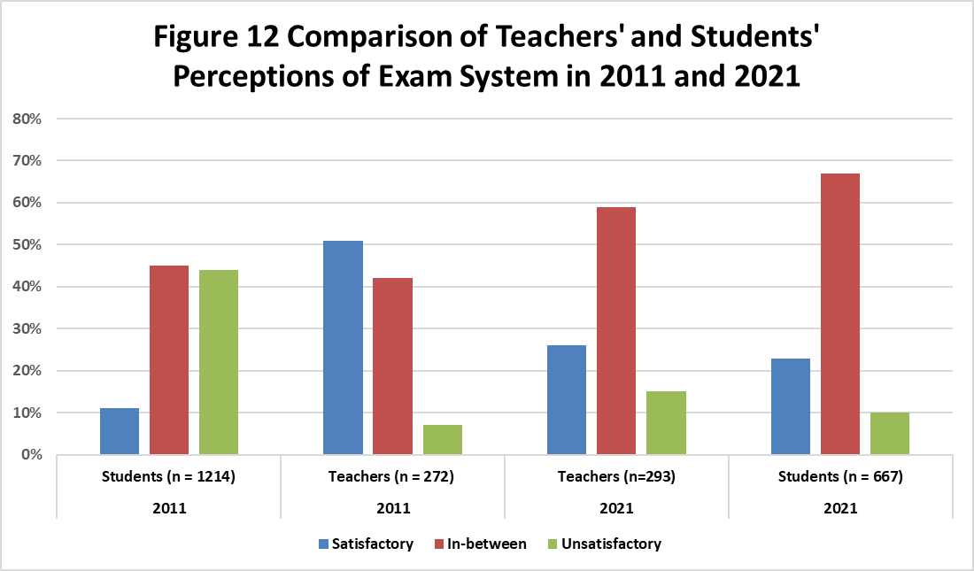

A comparison of the sample students’ and teachers’ satisfaction with the examination system in 2011 and 2021 is shown in Figure 12. In 2011, in general 17% - 20% of the sample teachers and students were satisfied with the exam system and fewer than 40% of both samples were dissatisfied. The remainder of both samples (44% - 50%) were in-between. The numbers are reversed in 2021. A third of both samples were satisfied with the exam system and 18% - 20% were dissatisfied and the remaining samples (46% - 48%) were in-between. This means a growing number of both teacher and student samples (about 15%) were satisfied with the exam system. However, more than half of both samples are in-between.
Both samples were asked to express their opinions on the exam system. In 2011, half of the sample teachers and 10% of the sample students found the exam system satisfactory and over 40% were in-between. In 2021, a quarter of both samples of students found the exam system satisfactory. Ten percent to fifteen percent found it unsatisfactory and a majority of both samples (59% - 68%) had mixed feelings. This finding means that the samples’ opinions on the exam system changed between 2011 and 2021. In the same way, both samples felt indifferent about whether to keep, abandon or modify the exam system. However, Tsai and Kuo (2008) found that teaching and learning activities primarily focused on how to prepare students for the examinations.
Teachers’ and Students’ Personal Opinions
As mentioned above, the voices of teachers who lived through the reform are very informative (Fullan, 1996). Below are typical comments on various themes. Words in italics are Google translations of responses.

Teachers’ Voices
108 Curriculum Reform
The Reform made numerous changes. A third of the sample teachers added comments. The following are typical ones:
The 108 Syllabus has increased the burden on teachers of designing courses and preparing lessons that include “new, elective, independent study, and extracurricular-related courses.”
High school students must study in a variety of ways, inside and outside the classroom, in clubs, and for competitions.
These comments confirmed the additional workload the Reform put on teachers and students (Chen, et al., 2020). The comments also indicated that teachers had more autonomy to create their own teaching materials (Coudenys, et al., 2022). The latter comment confirmed Cho’s (2021) reflections.
Diversified Curriculum 課程多元
Diversified curriculum is used interchangeably with 108 Curriculum. This quote by a science teacher is the key to the reform: Because the curriculum is diverse, the students' learning methods and the teaching emphasis are also diverse. Several sample teachers mentioned that the Special Education program and resources have increased (MOE, 2022).
Connection to Real-life
Contextualized and life-oriented, and began to lead students to think about the connection between text and life, and how to solve life problems.
This quote indicates that the courses met curriculum goals (Chen, Yang, et al., 2020; MOE, 2014). Student outcomes are competency-based involving real-life applications (Wu & Chan, 2018; Coudenys, et al., 2022).
Teaching Strategies
Even though the always/often usage of SCL strategies remained at 25% in all five subjects (Figures 7-11 and Table 3), a third of the sample teachers voiced their changed strategies:
Students have shifted from passive learning to being active learners
More group teaching, active teaching. practical, and. project production.
These comments illustrate how key-competencies education was implemented (Wu & Chan, 2018) and the paradigm shift to SCL pedagogies (Cho, 2012).
Integration of Technology (IT)
A number of respondents mentioned these advances:
The teaching methods are becoming more and more technological.
We advocate the use of tablet and teaching, and technology education.
IT has doubled to 30% from 2011 to 2021 (Table 3). The new guidelines require the inclusion of IT learning for every subject (Education International, 2022).
Examinations System
Over thirty sample teachers made the following comments:
“Changes in the examination system.”
“The test questions become longer and use life-like issues and transferable abilities.”
These typical comments confirmed the changes made by College Entrance Examination Center (2022).

Students’ Voices
Sample students were asked to express their opinions in one sentence. Below are typical comments:
Teaching and Evaluation Strategies:
Lively classrooms, more teaching items, and more diverse classes.
The teaching materials are different, more life-oriented, lively and close to students' life.
Students learn more in class, and in extracurricular clubs, and competitions.
Real-life Connections
Emphasis on practical courses, emphasizing project production.
In technical courses, varying skills/trades are offered.
A few respondents mentioned this: Insufficient teaching resources in rural villages.
Conclusions and Discussion of Research Questions
Reform in education often demands changes in practice that challenge classroom teachers (Fullan, 2000). This study drew attention to the Reform that has had direct impact on teachers and, in turn, on students and parents in Taiwan. The 12-Year Curriculum was implemented in 2019. A comparison of the survey results from sample teachers’ and students’ surveys in 2011 and 2021 indicates that the reform effort has little impact on teaching and student evaluation strategies. Perhaps it is still early into the Reform. Most sample teachers are staying with their teacher-directed tradition. There are indications that about one-quarter of the teachers are exploring SCL and IT strategies. Student evaluation methods remain unchanged. Both sample teachers and students stated that traditional tests, classwork, homework, and exams were most often used. Classroom management remained at 20% - 25% according to sample students, as compared to 6% for sample teachers. On average, each sample teacher had a handful of students with special needs integrated in their classes. Accommodation strategies used included modification (30%), extra time/help (28%), differentiation (12%) and adaptation (12%). All of which are in accordance with the Special Education Act (MOE, 2022). Teachers indicated that there was adequate support in terms of resources and professional development. However, resources are needed in rural schools.
Research Question 1: Compare the perceptions of students and teachers of the Basic Education Reform in 2011 and 2021 in Taiwan.
In general, over half (56%) of the teacher respondents were satisfied with the reforms in 2021. Only 3% were dissatisfied, and 41% were in between. Some sample teachers are still struggling with transitioning. As in 2011, most sample teachers indicated that there was adequate support in terms of resources (84%) and professional development (62%). Regarding teaching practices, both participant teachers and students said that subject teachers were using mostly teacher-directed strategies. Dominant strategies used were teacher talk (over 90%), followed by individualized learning (35% - 50%), and questioning (50%), all teacher-directed strategies (Figures 1, 7–11 and Table 3). Both samples agreed that discussion lessons were always/often used in one-third of the classes. Except for math, IT has doubled to 27% in 2021. The use of AV has also doubled but to a lesser extent. As for student-centered (SCL) strategies, one of the key initiatives of the Basic Education Reforms, less than one-third of the sample teachers and about a fifth of the sample students indicated that their subject teachers always/often used them in classes. In 2011, 14% of sample teachers claimed that they always/often have classroom management issues. The percentage dropped to 9% in 2021. The percentage drop for sample students was from 28% to 26%. Perhaps this is the reason why teachers prefer teacher-directed strategies. As for student evaluation, both sample teachers and students claimed that traditional tests, class work, homework, and examinations were always/often used in 2011 and 2021 (Figure 2). However, in 2021, twice as many sample teachers claimed that they always/often used group work (13% - 28%) and student presentation/projects (12% - 25%) which are SCL practices. In open-ended comments in the surveys on changes in the past five years, about 80% of the teacher respondents made comments/suggestions. Of these, about half were related to the Basic Education reform. The following are typical comments related to this question:
Diversified curriculum, diversified teaching materials, multivariate assessment.
Students' learning methods and teaching strategies are more diversified.
Change in curriculum, reduce and modify, no change in exam system.
Research Question 2: To what extent have teachers implemented the Competency-based Secondary Reform in Taiwan?
Key-competencies teaching is a key component of the Basic Education Reform in Taiwan. Wu & Chan (2018) outlined three key-competencies in Table 1. The first component is “Student-Centered Learning” or SCL. The second and third components are the emphases on real-life applications and interdisciplinary learning. The reform made several other significant changes. They include adding new courses related to local and international issues, and modifying the senior high school entrance examination (Gouëdard, et al., 2020; Wang et al., 2023; Chen, Yang et al., 2020; Fang, 2019). In practice, survey data from sample teachers (Figure 1) and students (Figures 7-11 and Table 3) indicate that subject teachers were using mostly traditional strategies (teacher talk, individual work and questioning). Discussion lessons were always/often used in one-third of the classes, and the use of IT has doubled to 25% in 2021. As for SCL strategies, results in Table 3 indicate that from sample students’ perspectives, in 2021, a quarter of their subject teachers conducted activities-based lessons. A little more than one-sixth of the subject teachers always/often used group work; and a handful of teachers always/often held student presentations lessons. Demonstration/experiment/skits lessons are intended for science, English and Chinese classes. For example, role play can be used in Monkey King and Romeo and Juliet stories. Except for science where there is a small increase in teacher demonstrations (from 15% to 22% always/often used), their usage was minimal in both 2011 and 2021. Data from sample teachers in Figure 1 revealed similar results. We can conclude that about a third of the sample teachers and about a fifth of the sample students thought that their subject teachers always/often used SCL in classes in 2021. In open-ended comments by sample students, quite a few sample students suggested that their teachers used SCL in their classes, for example: Lively classrooms, more life-oriented applications. Open-ended responses by sample teachers indicate a clear understanding of the Reform initiatives, in particular, SCL strategies and real-life applications. For example: two typical comments are: “Students have shifted from passive to active learning, for example, group teaching and active teaching.” and “Emphasis on practical applications, cooperative learning and. project production.” These comments and survey results indicate that key-competencies education was implemented by approximately a quarter of sample teachers. More importantly, examinations will include situational questions to assess whether students can integrate knowledge and skills, as well as questions with cross-disciplinary themes (College Entrance Examination Center, 2022). The reform demands a paradigm shift from teacher-centered to student-centered pedagogy and focuses on life experiences to cultivate students’ key-competencies (Wu & Chan, 2018; Cho, 2012). One sample student summed up the key-competencies reform the best. Hopefully others can do the same:
Students must study in a variety of ways, inside and outside the classroom, clubs, and competitions (disciplines/talents). Students with sufficient ability can handle it appropriately. Students with intermediate ability will be flustered.
Discussion
The competency-based reform in Taiwan attempts to change traditional modes of teaching and learning to SCL and integrate knowledge and skills, as well as questions with cross-disciplinary themes (Gouëdard et al., 2020). Results in our study indicate that it is not easy to implement due to the high-stakes examinations system and societal and parental inputs. Huang & Asghar (2016) also found that many parents held similar beliefs. They reported many secondary science teachers felt incompetent in implementing the new curriculum. Kyriacou and Chien (2004) had similar findings in an earlier study.
As for IT and the use of AV, perceptions of sample teachers and students are similar. Their perceptions of the use of technology and AV has doubled to 30% and 18% respectively from 2011 to 2021 (Figures 1, 7-11, Table 3). These percentages are low considering Taiwan is one of the most technology-advanced countries and the new guideline requires the inclusion and use of IT learning for every subject (Education International, 2022).
As for classroom management issues, in 2021, about a quarter (25%) of the sample students claimed that the classroom behaviour of other students was always/often making it difficult for them to learn. This is a slight reduction from 2011 (Figure 7 to 11 and Table 3). Only 5% of the sample teachers felt that they always/often had classroom management problems in 2021, compared with 11% in 2011 (Figure 1). However, classroom disruptions remained a major concern for about a quarter of the sample students in both 2011 and 2021. Perhaps greater usage of SCL, IT and real-life application lessons may generate more interest in classes and hence less management issues. As indicated in Figure 6, more than one-third (35%) of the respondent teachers indicated a greater need for PD in classroom management techniques. As for student evaluation strategies, sample students stated that tests, exams, class work and homework/assignments were always/often used, the same as their teachers (Figure 2).
Recommendations
School curricula in Taiwan have mostly emphasized content. Its education system focuses too heavily on examinations, and rote memorization rather than the creative application of knowledge (Lin, Wang & Chang, 2014). Another concern is that the Taiwanese cultural values and parental and teacher preferences are ill-equipped to cultivate the new approaches (Tsai & Kuo, 2008; Chiu & Whitebread, 2011; Kyriacou & Chien, 2004; Huang & Asghar, 2016). In spite of these concerns, the 12-Year Curriculum Reform or 108 syllabus initiatives were implemented. Student-centred learning (SCL) and a focus on life experiences to cultivate students’ key-competencies were at the core of the Reform. Another issue is its high-stakes examinations. Samples’ opinions on the exam system differed between 2011 and 2021. (Figure 12) felt indifferent about whether to keep, abandon or modify the Exam system. In Taiwan, parents hold very high expectations for their children’s performance (Fang, 2019). Many teachers and parents also felt that the teaching and learning activities should primarily focus on how best to prepare students for examinations (Baron and Chen 2012, Tsai and Kuo, 2008). Some teachers insist that direct methods of teaching are straightforward and effective, whereas SCL pedagogy is too complex and confusing for students (Huang and Asghar, 2016).
The 108 Curriculum Reform which emphasizes core competency teaching and assessment. made several significant changes. They include moving from knowledge to competency orientation, integrating subject matter and prominent issues into learning areas, adding new courses in response to local and international issues, and modifying the senior high school entrance examination. It will assess whether candidates can integrate knowledge and skills to answer situational questions, as well as cross-unit/cross-field/cross-disciplinary themes.
A sample teacher voiced a common concern: “The 108 Syllabus has increased the burden on teachers in designing courses and preparing lessons’’ that include “new, elective, independent study, and extracurricular-related courses.” The problem lies in the implementation of the Reform. New demands are placed on teachers as they strive to implement the newly reformed competency-oriented curriculum with renewed pedagogical practices. Professional Development (PD) workshops are key for supporting teachers in new initiatives such as SCL (Smit & du Toit, 2016). PD increases comfort and skill levels for implementing new curricula and strategies by promoting confidence and a greater understanding of objectives (Lia, 2016). Figure 6 indicates the professional development (PD) needs by sample teachers. Perhaps more PD activities and demonstrations would help, for example, role-play in English and Chinese, demonstrations in science classes, using manipulatives and models in math classes, integration of technology and AV and performance assessment strategies. A recent survey of 1,500 secondary teachers by the National Teachers’ Association (NTA) has revealed that 92 per cent of teachers suffered from work overload implementing the new curriculum. Three-quarters (78.5 per cent) of the surveyed teachers explained that preparatory work increased significantly (Education International, 2022). All educators struggled to create new tasks and implement new modes of teaching and evaluation. In-service professional development, demonstration classes, teacher competitions and resources seemed adequate and should continue.

References
Authors, Ryan, T.; Noel, K.; Cook, L.; and Reis, G. (2011). Secondary Reform from the Perspectives of Teachers and Students in Six Countries. Symposium presented at annual meeting for American Educational Research Association (AERA), New Orleans, LA, U.S.
Authors (2011). Perceptions of Students and Teachers on Mathematics Reforms in Canada, China, Taiwan, and Jamaica.Paper presented at annual meeting for American Educational Research Association (AERA), New Orleans, LA, U.S.
Author (2011). Perceptions of parents, teachers, and students on secondary education reforms in China. Peabody Journal of Education, 87(2), 267–282.
Author and Ryan, T. (2013a). “Teachers' and Students' Perceptions of Secondary Reform and Implementation: A China and Canada Comparison”. In Yvonne. Hébert & Ali A. Abdi (Eds.), Critical perspectives on international education (pp. 263–278). Sense Publishers.
Author and Noel, K. (2013b). “The Perceptions of Teachers in Sierra Leone's Secondary Education Reform”. In Robert A. DeVillar, Binbin. Jiang, & Jim. Cummins (Eds.), Transforming education: Global perspectives, experiences and implications. Peter Lang Publishing.
Author, Mangali, G., Reganit, A. R., and Swan, B. (2019). “Understanding the Ecologies of education reforms: Comparing the perceptions of secondary teachers and students in the Philippines”. International Journal of Educational Reform, 28(3), 278–302.
Author, Ramsawak-Jodha, N., Wintz, P., Anderson, S., and Hutton, D. (2020). “Understanding the Ecologies of education reforms: Comparing the perceptions of secondary teachers and students in Jamaica, Guyana, and Trinidad and Tobago”. Caribbean Journal of Mixed Methods Research, 1(1), 134-166.
Author (2021). Understanding the Ecologies of Education Reforms: Comparing the Perceptions of Secondary Teachers and Students in Mexico. International Journal of Educational Reform, 31(2), 135-167
Baron, A., and Chen, H-L S. (2012). Looking in a science classroom: exploring possibilities of creative cultural divergence in science teaching and learning. Cultural studies of Science Education, 7(1), 93-101.
Bremner, N. (2021). “The multiple meanings of ‘student-centred’ or ‘learner-centred’ education, and the case for a more flexible approach to defining it”. Comparative Education, 57(2), 159–186.
Chen, H. L. S. and Huang, H. Y. (2017). Advancing 21st century competencies in Taiwan. National Taiwan Normal University, 1-21.
Chen, P., Yang, C-L, Hung, Y-S., Hung, W-J., and Chen. M-J. (2020) Exploring High-School Readiness for Change in Taiwan from a Lens of Policy Design. Journal of Educational Research and Development, 16(3), 93-127.
Chiu, M. S., and Whitebread, D. (2011). Taiwanese teachers’ implementation of a new ‘‘Constructivist Mathematics Curriculum’’: How cognitive and affective issues are addressed. International Journal of Educational Development, 31(2), 196–206.
Cho, Y. (2012) “Taiwan’s New ‘108 Curriculum.” Taiwan Times, April 17, 2021.
Clarke, D. M. (1997). “The changing role of the mathematics teacher”. Journal for Research in Mathematics Education, 28(3), 278–308.
College Entrance Examination Center (2022) 111 Academic Year Subject Ability Test Planning and Directions. https://www.ceec.edu.tw/
Coudenys, B., Strohbach, G., Tang, T., and Udabe, R. (2022). On the Path Toward Lifelong Learning: An Early Analysis of Taiwan’s 12-Year Basic Education Reform. In: Reimers, F.M., Amaechi, U., Banerji, A., Wang, M. (Eds) Education to Build Back Better. (pp. 75-98). Springer.
Creswell, J. W., Plano Clark, V. L., Gutmann, M. L., and Hanson, W. E. (2003). Advanced mixed methods research designs. In A. Tashakkori & C. Teddlie (Eds.), Handbook of mixed methods in social and behavioural research (pp. 209–240). Sage.
Desimone, L. M., Smith, T. M., and Frisvold, D. E. (2010). “Survey measures of classroom instruction: Comparing student and teacher reports”. Educational Policy, 24(2), 267–329.
Earl, L., and Sutherland, S. (2003). “Student engagement in times of turbulent change”. McGill Journal of Education, 38(2), 329–343.
Education International (Oct 21, 2022) “Taiwan: Nine out of 10 teachers overworked implementing new curriculum.” https://www.ei-ie.org/en/item/23557:taiwan-nine-out-of-10-teachers-overworked-implementing-new-curriculum
Etikan, I., Musa, S. A., and Alkassim, R. S. (2016). “Comparison of convenience sampling and purposive sampling”. American Journal of Theoretical and Applied Statistics, 5(1), 1–4.
Fang, D-L (2019) An Inquiry into the Development and Review Process of the 12-Year Basic Education Curriculum Guidelines. Journal of Education Research, Taipei Issue, 298, 56=78.
Fullan, M. G. (1996). “Turning systemic thinking on its head”. Phi Delta Kappan, 78(6), 420–423.
Fullan, M. G. (2000). “The return of large-scale reform”. Journal of Educational Change, 1(1), 5–27.
Fullan, M. G. (2001). The New Meaning of Educational Change. Routledge.
Fullan, M. G., and Stiegelbauer, S. (1991). The New Meaning of Educational Change. Teachers College Press.
Gouëdard, P., Pont, B., Hyttinen, S., and Huang, P. (2020). Curriculum reform: A literature review to support effective implementation. OECD Education Working Papers No. 239.
Helsby, G. (1999). Changing teachers’ work. Open University Press.
Huang, Y.S. and Asghar, A. (2016) Science education reform in Confucian learning cultures: policymakers’ perspectives on policy and practice in Taiwan. Asia Pacific Science Education. 2 (3), 1-22.
Jin, Y, and Authors (2023) "Revisiting Secondary Education Reform in China: Comparing the Perceptions of Teachers and Students between 2011 and 2022," Chinese/English Journal of Educational Measurement and Evaluation | 教育测量与评估双语期刊: Vol. 4: Iss. 4, Article 3.
Kyriacou, C., and Chien, P. Y. (2004). Teacher stress in Taiwanese primary schools. Journal of Educational Enquiry, 5(2), 86–104.
Lai, Y-H (2022) Education reform through westernization in Taiwan: a case of transferring the constructivist-based mathematics curriculum from the United States, Journal of Asian Public Policy, Vol. ahead-of-print, 1-19.
Lam, C-C, Ho, C., Sui, E., and Wong, N.Y. (2002). Parents' Beliefs and Practices in Education in Confucian Heritage Cultures: The Hong Kong Case. Journal of Southeast Asian Education, 3(1), 99-114.
Lia, M. (2016). Using an observation coaching checklist to provide feedback to teachers. Journal of Catholic Education, 20(1), 311-323.
Lin, T-B, Wang, L-Y, Li, J-Y and Chang, C.M. (2014) Pursuing Quality Education: The Lessons from the Education Reform in Taiwan. Asia-Pacific Edu Res., 23(4), 813–822.
Lin, M-H, Chuang, T-F, and Hsu, H-P. (2014) The Relationship among Teaching Beliefs, Student-Centred Teaching Concept and the Instructional Innovation. Journal of Service Science and Management, 7, 201-210.
Ministry of Education (MOE) Taiwan (2022) Education in Taiwan 2022-23 (English version) https://stats.moe.gov.tw/bookcase/Education_in_Taiwan/111/index.html
MOE Taiwan (2014) General Guidelines of the 12-year Basic Education Curriculum (English version) https://www.naer.edu.tw/eng/PageSyllabus?fid=148
MOE Taiwan (2003). White paper for Science education. Taipei: Ministry of Education, Republic of China
National Association of Secondary School Principals (NASSP). (2004). Breaking ranks II: Strategies for leading high school reform. The Education Alliance.
Pan, H-L. W. and Wiens, P.D. (2023) An Investigation of Receptivity to Curriculum Reform: Individual and Contextual Factors The Asia-Pacific Education Researcher.
Penuel, W.R., Phillips, R.S., and Harris, C.J. (2014) Analysing teachers’ curriculum implementation from integrity and actor-oriented perspectives, Journal of Curriculum Studies, 46(6), 751-777.
Schweisfurth, M. (2011). Learner- centered education in developing country contexts: From solution to problem? International Journal of Educational Development. 31: 425-432.
Smit, T., and du Toit, P. (2016). Transforming beginner teacher mentoring interventions for social reform. South African Journal of Education, 36(3), 1-12.
Sun, C.-L. (2020) The Road Not Taken: An Analysis of Competence-oriented Education Policy. Journal of Education Research, 2020 (313), p.141-156.
Terrell, S. R. (2012). Mixed-methods research methodologies. Qualitative Report, 17(1), 254–280.
Tsai, C.-C., and Kuo, P.-C. (2008). Cram school students’ conceptions of learning and learning science in Taiwan. International Journal of Science Education, 30(3), 351–373.
Wang, T., Olivier, D.F., and Chen, P. (2023) “Creating Individual and Organizational Readiness for Change: Conceptualization of System Readiness for Change in School Education.” International Journal of Leadership in Education, Vol. ahead of print, 1–25.
Wiggins, G., and McTighe, J. (2005). Understanding by design, 2nd Ed. Alexandria, VA: Association for Supervision and Curriculum Development.
Wiles, J. W., and Bondi, J. C. (2014). Curriculum development: A guide to practice (9th ed.). Boston, MA: Pearson.
Wu, Y. S. (2001). Systems design: An analysis of the implementation process of Taiwan’s constructivist approach elementary mathematics curriculum. Atlanta, GA: Association for Educational Communications and Technology.
Wu, P.C., and Chan J.C. (2018) Reflecting on the perspective transformation of competency-based education. J Educ Res Dev. 14(2), 35-64. https://doi.org/10.3966/181665042018061402002. (in Chinese)

